**Emergency Information on Mobile**

Software Requirement Specification

By

Putchakarn Jaikon 542115031

Sawatdiporn Kitirot 542115065

Department of Software Engineering

College of Arts, Media and Technology

Chiang Mai University

Project Advisor

__________________________________

**Aj.Chartchai Doungsa-ard**

# Chapter One | Introduction

## Objective

Software Requirement Specification of Emergency Information on Mobile is the document that describes each function, process, software environment, and constraint. The document is based on the contract and project plan. It is created for software developer and software tester to more understanding in the requirement. The purpose of Emergency Information on Mobile is providing area for presenting information of help place for the users. Admin also can manage information of help place.

## Intended Audience and Reading Suggestions

The Software Requirement Specification was created for everyone that involved with the Emergency Information on Mobile. The document of Software Requirement Specification will make the benefit for people as following:

**1.2.1 Development Team**

• Make strategies and planning process convenient

• Improve the system in right needed and use for prioritize what process become first or what process should be after.

• Reference in testing system because tester will validate if the system is correct and appropriate.

• Verify and specify requirements to ensure the same understanding about requirements. The ensuring can help in working and discuss all detail about requirements for avoid any error in work.

• Control and guarantee qualities of the system to make it right regarding the standard and contract.

• Easier discussion all information about the system because the constant and reliability source of the system.

**1.2.2 Customer**

• Easy for users to understand about quality and limitation of the system.

• Ensure the same understanding about requirement.

## Project Scope

The objective of this software requirement specification is to specify requirements to establish the application that:

• Emergency Information on Mobile is a web application for both computer website and mobile devices.

• Emergency Information on Mobile for mobile devices supports android operating system.

• Emergency Information on Mobile provides offline map and last downloaded information of help places.

• Emergency Information on Mobile supports English language.

• Emergency Information on Mobile provides admin to manage the information of help place, such as add, edit and remove help place.

## User Characteristic

• The group of person who already to use online map and offline map. The user of the application that will receive the information of help place to call and get an address.

• The group of person who manage the information of the help place.

## 1.5 Acronyms and Definitions

**1.5.1 Acronyms**

EIOM Emergency Information on Mobile

SRS Software Requirement Specification

URS User Requirement Specification

UI User Interface

**1.5.2 Definitions**

|  |  |
| --- | --- |
| Feature | Transformation of input parameters to output parameters based on a specified algorithm. It describes the functionality of a product. Used for requirements analysis, design, coding, testing or maintenance. [IEEE90] |
| IEEE | Institute for Electrical and Electronics Engineers. Biggest global interest group for engineers of different branches and for computer scientists. [IEEE90] |
| Requirement | (1) A condition or capability needed by a user to solve a problem or achieve an objective. (2) A condition or capability that must be met or processed by system or system component to satisfy a contract, standard, specification, or other formally imposed document. (3) A documented representation of a condition or capability as in definition (1) or (2). [IEEE90] |
| Specification | Precise description of an activity or work product which serves as basis or input for further activities or work product. A specification can comprise requirements to a product and how they will be solved. Different parts of a specification (e.g. what is to be done, how it will be done) must not be mixed. [IEEE90] |
| Design | The period of time in the software life cycle during which the designs for architecture, software component, interfaces and data are created, documented, and verified to satisfy requirements. [IEEE90] |
| UML | Unified Modeling Language. Standardized notation for Modeling design descriptions, architecture or scenarios. Not depending on a specific method. Issued and maintained by the Object Management Group (OMG). [IEEE90] |
| Use case | (1) Concept to describe a system based on usage of system resource by its environment. Characterized by an objective set of interactions within and at the borders a scenario (Usage approach, operational scenario) from the perspective of this user. [IEEE90] |

# Chapter Two | Specific Requirement

## 2.1 Use Case Scenarios

**•Emergency Information Server**

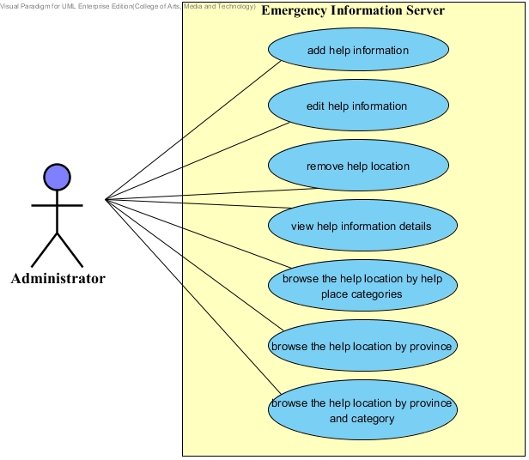

**Figure 1 Show use case of “Emergency Information Server”**

**•Emergency Information on Mobile**

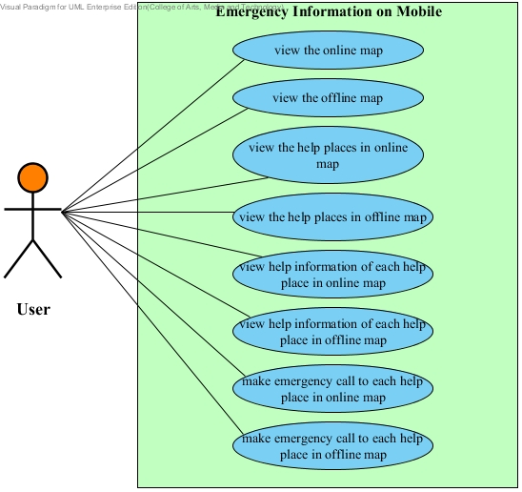

**Figure 2 Show use case of “Emergency Information on Mobile”**

# Chapter Three | Functional Requirement

## 3.1 User Requirement Specification

**• Feature 5: Manage Information System**

[URS-1]: The administrator can add help information, which includes name, address, district, province, zip code, phone number, category, latitude and longitude.

[URS-2]: The administrator can edit help information, which includes name, address, district, province, zip code, phone number, category, and coordinates location.

[URS-3]: The administrator can remove help location.

[URS-4]: The admin can view help information of each help place.

[URS-5]: The administrator can browse the help location by help place category.

[URS-6]: The administrator can browse the help location by province of Thailand.

[URS-7]: The administrator can browse the help location by category and province of Thailand.

**• Feature 1: Map and Help Information System**

[URS-8]: The user can view the online map with their current location.

[URS-9]: The user can view the offline map with their current location.

[URS-10]: The user can view the help places in online map with user’s current location.

[URS-11]: The user can view the help places in offline map.

[URS-12]: The user can view help information of each help place in online map.

[URS-13]: The user can view help information of each help place in offline map.

[URS-14]: The user can make emergency call to each help place in online map.

[URS-15]: The user can make emergency call to each help place in offline map.

## 3.2 Software Requirement Specification

## รอไกด์ และ เพิ่ม SRS

**UC08:** View the online map

The user can view the online map with their current location on the online map page.

**Actor**

Users

**Prerequisite**

The user has to turn on GPS and enter to the online map page.

**Input**

|  |  |  |  |
| --- | --- | --- | --- |
| **Name** | **Description** | **Example** | **Remarks** |
| Latitude | Latitude of user’s current location should be the DD (decimal degrees) format, which base on Google maps. | 18.809011 | Latitude must be decimal number of degrees. |
| Longitude | Longitude of user’s current location should be the DD (decimal degrees) format, which base on Google maps. | 99.218742 | Longitude must be decimal number of degrees. |

**Output**

The online map is shown with the current location of the user.

**Flow of Execution**

1. The user enters to the online map.
2. The system obtains the latitude and longitude of the user’s current location.
3. The system get map from Google Maps.
4. The system provides online map UI, which shows online map with the user’s current location.

**Use Case:** View the online map (UC08)

**URS-8:** The user can view the online map with their current location.

**System Requirement Specification:**

SRS…

**UC09: View the offline map**

The user can view the offline map with their current location on the offline map page.

**Actor**

Users

**Prerequisite**

The user has to turn on GPS and enter to the offline map page.

The user has to download Thailand map from MapsWithMe application.

The user installs MapsWithMe application on their device.

**Input and Output**

|  |  |  |  |
| --- | --- | --- | --- |
| **Name** | **Description** | **Example** | **Remarks** |
| Latitude | Latitude of user’s current location should be the DD (decimal degrees) format, which base on MapsWithMe. | 18.809011 | Latitude must be decimal number of degrees. |
| Longitude | Longitude of user’s current location should be the DD (decimal degrees) format, which base on MapsWithMe. | 99.218742 | Longitude must be decimal number of degrees. |

**Output**

The offline map is shown with the current location of the user.

**Flow of Execution**

1. The user enters to the offline map.
2. The system connects MapsWithMe application.
3. The system obtains the latitude and longitude of the user’s current location.
4. The system provides offline map UI, which shows offline map with the user’s current location.

**Use Case:** View the offline map (UC09)

**URS-9:** The user can view the offline map with their current location.

**System Requirement Specification:**

SRS…

**UC10: View the help places in online map**

All help places will show in an online map. The user can view all help places on the map.

**Actor**

Users

**Prerequisite**

The user has to connect with the internet.

The user has to turn on GPS and enter to the online map page.

**Input**

|  |  |  |  |
| --- | --- | --- | --- |
| **Name** | **Description** | **Example** | **Remarks** |
| Latitude | Latitude of user’s current location should be the DD (decimal degrees) format, which base on Google maps. | 18.809011 | Latitude must be decimal number of degrees. |
| Longitude | Longitude of user’s current location should be the DD (decimal degrees) format, which base on Google maps. | 99.218742 | Longitude must be decimal number of degrees. |

**Output**

All help places shows on the online map.

**Flow of Execution**

1. The user enters to the online map.
2. The system get map from Google Maps.
3. The system retrieve help places from server.
4. The system show all help places on an online map.

**Use Case:** View the help places in online map (UC10)

**URS-10:** The user can view the help places in online map.

**System Requirement Specification:**

SRS…

**UC11: View the help places in offline map**

The user can view the location of help places, where are loaded and saved in the user’s device.

**Actor**

Users

**Prerequisite**

The user enters to the offline map page.

The user has to turn on GPS.

The user has to download Thailand map from MapsWithMe application.

The user installs MapsWithMe application on their device.

There is information of help place, which is loaded, on the user device.

**Input**

The user enters to the offline map.

**Output**

The help location shows on the offline map.

**Flow of Execution**

1. The user enters to the offline map.
2. The system connects MapsWithMe application.
3. The system retrieves the loaded help information from the user’s device.
4. The system shows help places on the offline map UI.

**Use Case:** View the help places in offline map (UC11)

**URS-11:** The user can view the location of help places in offline map.

**System Requirement Specification:**

SRS…

**UC12:** View help information of each help place in online map

The user can view the help information of each help place. The help information is name, address, district, province, zip code, and phone number of help place.

**Actor**

Users

**Prerequisite**

The user enters to the online map page, which shows the location of help place.

**Input**

The selected help place object.

**Output**

The help information of the selected help place, which is name, address, district, province, zip code, and phone number of help place.

**Flow of Execution**

1. The user selects the help place they want to see information on the online map page.
2. The system retrieves the help information from the system database.
3. The system provides information UI to show the help information, which are name, address, district, province, zip code, and phone number.

**Use Case:** View help information of each help place in online map (UC12)

**URS-12:** The user can view help information of each help place in online map.

**System Requirement Specification:**

SRS…

**UC13:** View help information of each help place in offline map

The user can view the help information of each help place. The help information is name, address, district, province, zip code, and phone number of help place.

**Actor**

Users

**Prerequisite**

The user enters to the offline map page, which shows the location of help place.

There is information of help place, which is loaded, on the user device.

**Input**

The selected help place object.

**Output**

The help information of the selected help place, which is name, address, district, province, zip code, and phone number of help place.

**Flow of Execution**

1. The user selects the help place they want to see information.
2. The system retrieves the loaded help information from the user’s device.
3. The system provides information UI to show the help information, which are name, address, district, province, zip code, and phone number.

**Use Case:** View help information of each help place in offline map (UC13)

**URS-13:** The user can view help information of each help place in offline map.

**System Requirement Specification:**

SRS…

**UC14:** Make emergency call to each help place in online map

The user can call to each help place directly from the application.

**Prerequisite**

The user enters to the online map page, which shows the location of help place.

**Actor**

Users

**Input**

The selected help place object, where the user want to make a call.

**Output**

The system connects to call system of the device and make a call to the selected help place.

**Flow of Execution**

1. The user selects the help place they want to call on an online map.
2. The system retrieves the help information from the system database.
3. The system provides the information of the selected help place with call UI.
4. The user selects phone number to call.
5. The system call to the selected help place.

**Use Case:** Make emergency call to each help place in online map (UC14)

**URS-14:** The user can make emergency call to each help place in online map.

**System Requirement Specification:**

SRS…

**UC15:** Make emergency call to each help place in offline map

The user can call to each help place directly from the application.

**Actor**

Users

**Prerequisite**

The user enters to the offline map page, which shows the location of help place.

There is information of help place, which is loaded, on the user device.

**Input**

The selected help place object, where the user want to make a call.

**Output**

The system connects to call system of the device and make a call to the selected help place.

**Flow of Execution**

1. The user selects the help place they want to call on an offline map.
2. The system retrieves the loaded help information from the user’s device.
3. The system provides the information of the selected help place with call UI.
4. The user selects phone number to call.
5. The system call to the selected help place.

**Use Case:** Make emergency call to each help place in offline map (UC15)

**URS-15:** The user can make emergency call to each help place in offline map.

**System Requirement Specification:**

SRS…